PLEASE ADD THE TITLE OF YOUR RESEARCH
First Name Last Name¹, Ali Nadjai², Naveed Alam²,
¹ Affiliation, City, Country
² Ulster University, Belfast, United Kingdom

ABSTRACT
Abstract length should be around 200-250 words.

INTRODUCTION
Full paper must be prepared using this template and submitted in PDF and DOC (Word) format in high quality print. Please do not insert page numbers and do not secure the PDF file!

HEADINGS
Headings and subheadings should follow the format provided.

Paper, authors and affiliation
Title format: 14pt Times New Roman, bold, capital letters; centre adjusted. Please use the style, “Title”. The heading of abstract is written using style, “Main”, as done in this format.
Authors are listed with full names, with affiliation and contacts. This must be done using “Authors” style given in the template.

Paper size, margins and numbering
Please use page size A4. The text should fit exactly into the “type area” and must be justified using “justify”. For A4 size paper the margin settings are “moderate”: Top: 2.54 cm; Bottom: 2.54 cm; Left: 1.91 cm; Right: 1.91 cm. Table 1 summarizes the margins applied.
Please do not insert page numbers.

Sections
The paper starts with the ABSTRACT, followed by the consecutively numbered main sections. Include a list of numbered references at the end of the manuscript (use the template format). Acknowledgments are optional.

Paper length and language
Preferable paper length is 8-10 pages of size A4, however, the maximum length of 12 pages is allowed.
Language of the paper must be English. Please proofread your paper and refine the content to the best of your capabilities.

Submission deadline
Please submit your full paper, before the submission deadline, using the EasyChair link provided on the symposium website and/or page.
We would like to emphasize that abstract acceptance does not mean automatic acceptance of your paper. The extended papers are peer reviewed, and thus the final decision for paper acceptance will be made on the basis of this final paper review, after the final paper submission.
The file name must contain the ID Number, corresponding to the accepted abstract.

sECTION HEADINGS AND TEXT STYLE

Heading 1
Style of section headings: Capital bold letters, Times New Roman 12 pt. Line spacing before and after a heading is 18 pt and 4 pt, respectively. Please use the preset style “Heading 1” from this format.
Use consecutive numbering of the sections; the preset style comes with automatic numbering.

Heading 2
Secondary headings are typed in, Times New Roman 12 pt with each word starting with a capital letter and all bold (Use style “Heading 2”). Please limit the depth of headings to major and secondary headings where possible.

Heading 3
The tertiary headings must be avoided, but in case where this is unavoidable, please type these in, Times New Roman 12 pt with the first capital letter and in Italics (use style “Heading 3”).

Normal text style and list
The normal text is typed in Times New Roman 11 pt, justified with single line spacing.
For numbered or bulleted list please use the provided style templates
- List numbered
- List bullet.

FIGURES, TABLES AND EQUATIONS

Tables
Tables prepared in simple/basic word format are preferred. Tables must be referred in the text as Table 1, using “cross reference” option. The font size in the table shall not be smaller than 10 pt.
Table 1: I am the first table (add reference, if needed)
IFireSS2025 | IFireSS2025 | IFireSS2025 | IFireSS2025
IFireSS2025 | IFireSS2025 | IFireSS2025 | IFireSS2025
IFireSS2025 | IFireSS2025 | IFireSS2025 | IFireSS2025
IFireSS2025 | IFireSS2025 | IFireSS2025 | IFireSS2025
IFireSS2025 | IFireSS2025 | IFireSS2025 | IFireSS2025
IFireSS2025 | IFireSS2025 | IFireSS2025 | IFireSS2025
IFireSS2025 | IFireSS2025 | IFireSS2025 | IFireSS2025

Equations
Use the equation editor of Word with settings, 11pt Cambria Math. Equations must be numbered. An example is given in Eq. (1).
$C= \frac{F-32}{1.8}$ (1)
Where,
C is the temperature in Celsius,
F is the temperature in Fahrenheit

Figures, diagrams, illustrations
Figures, diagrams, illustrations should have a resolution of 600 dpi. Reference to the figures must be given in the text. Single figure arrangement is shown in Figure 1 while the two-column figure arrangement as shown in Figure 2. In the second figure, a table without borders is used for a better arrangement. The font size in the figures shall not be smaller than 10 pt. Figures must be referred in the text as Figure 1 and Figure 2, using “cross reference” option.

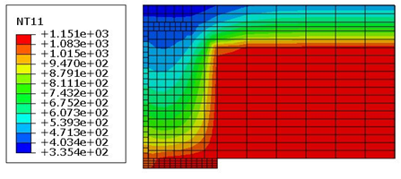
Figure 1: I am Figure 1(add reference, if needed)

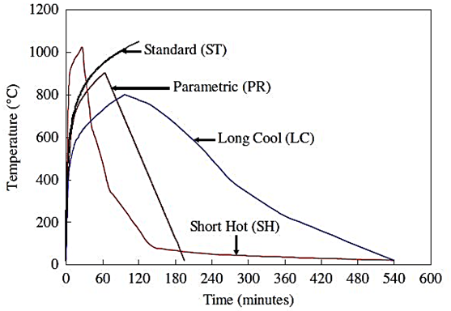  (a) | 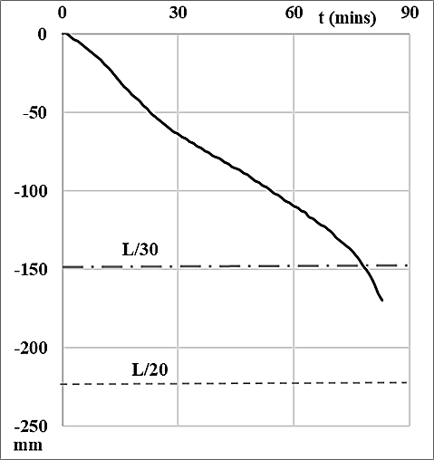  (b)
Figure 2: I am Figure 2, (a) I am part (a) (add reference, if needed), I am part (b) (add reference, if needed)

CONCLUSIONS
For convenience, please add concluding remarks as bullet points. This section is mandatory.

Acknowledgment
Acknowledgments are optional.
Numbered reference list shall be given as follows; the numbering corresponds to citation order in the manuscript (IEEE).

REFERENCES
- Author(s) Last name, Initial(s). (Year) 'Title of article', Title of Journal, Volume number (Issue number), Page numbers. DOI or URL if available.
- Nadjai A., Naveed A., Charlier M., Vassart O., Welsh S., Glorieux A., Sjostrom J. (2022). ‘Large scale fire test: The development of a travelling fire in open ventilation conditions and its influence on the surrounding steel structure’, Fire Safety Journal, Volume 130, 103575, ISSN 03797112. DOI: 10.1016/j.firesaf.2022.103575
- Author(s) Last name, Initial(s). (Year) 'Title of paper', Title of conference proceedings, Location, Date of conference. Publisher (if applicable), Page numbers.

