PLEASE ADD THE TITLE OF YOUR RESEARCH

First Name Last Name1, Ali Nadjai2, Naveed Alam2,

1 Affiliation, City, Country

2 Ulster University, Belfast, United Kingdom

ABSTRACT

Abstract should be prepared using the template and submitted in PDF and DOC (Word) format in high quality print. Please do not secure the PDF file! Please use IEEE referencing style [1] as given in the template. The length of abstract must not exceed 2 pages. The normal text is typed in Times New Roman 11 pt, justified with single line spacing.

The abstract must contain a brief background, problem statement, an overview of the aims and objectives, a brief of the methodology used and information on the (expected) results.

Authors must also include 4 keywords.

Tables prepared in basic word format are preferred. Tables must be referred in the text using the format as Table 1 (using “cross reference” option). The font size in the table shall not be smaller than 10 pt.

Table 1: I am the first table (add reference, if needed)

|  |  |  |  |
| --- | --- | --- | --- |
| **IFireSS2025** | **IFireSS2025** | **IFireSS2025** | **IFireSS2025** |
| IFireSS2025 | IFireSS2025 | IFireSS2025 | IFireSS2025 |
| IFireSS2025 | IFireSS2025 | IFireSS2025 | IFireSS2025 |
| IFireSS2025 | IFireSS2025 | IFireSS2025 | IFireSS2025 |
| IFireSS2025 | IFireSS2025 | IFireSS2025 | IFireSS2025 |
| IFireSS2025 | IFireSS2025 | IFireSS2025 | IFireSS2025 |
| IFireSS2025 | IFireSS2025 | IFireSS2025 | IFireSS2025 |

Figures must be referred in the text using the format as Figure 1 (using “cross reference” option).

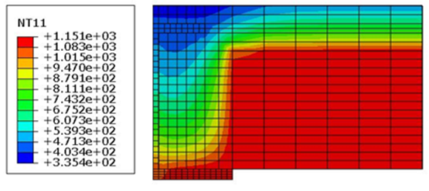

Figure 1: I am Figure 1 (add reference, if needed)

**Keywords:** IFireSS2025, Fire Safety, Testing, Computational Modelling

REFERENCES

1. Author(s) Last name, Initial(s). (Year) 'Title of article', *Title of Journal*, Volume number (Issue number), Page numbers. DOI or URL if available.
2. Nadjai A., Naveed A., Charlier M., Vassart O., Welsh S., Glorieux A., Sjostrom J. (2022). ‘Large scale fire test: The development of a travelling fire in open ventilation conditions and its influence on the surrounding steel structure’, *Fire Safety Journal*, Volume 130, 103575, ISSN 03797112. DOI: 10.1016/j.firesaf.2022.103575
3. Author(s) Last name, Initial(s). (Year) 'Title of paper', Title of conference proceedings, Location, Date of conference. Publisher (if applicable), Page numbers.